**Topics: Normal distribution, Functions of Random Variables**

1. The time required for servicing transmissions is normally distributed with *μ* = 45 minutes and *σ* = 8 minutes. The service manager plans to have work begin on the transmission of a customer’s car 10 minutes after the car is dropped off and the customer is told that the car will be ready within 1 hour from drop-off. What is the probability that the service manager cannot meet his commitment?
2. 0.3875
3. 0.2676
4. 0.5
5. 0.6987

Answer - B. 0.2676

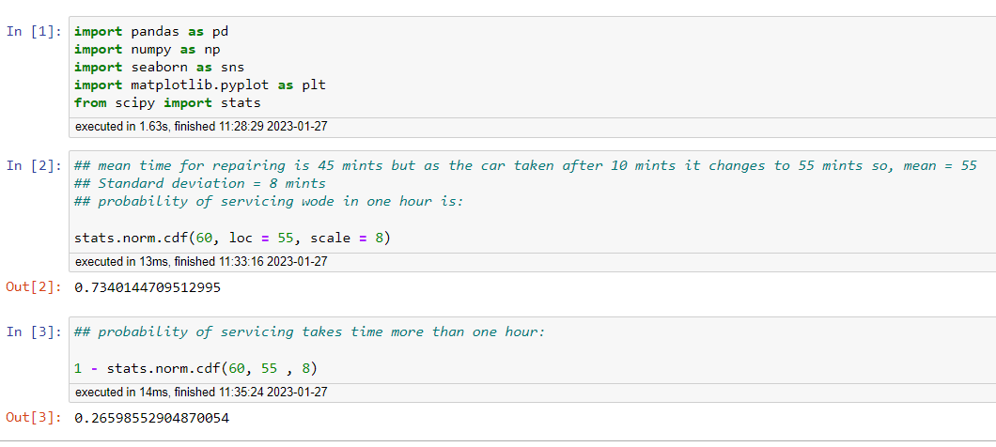

1. The current age (in years) of 400 clerical employees at an insurance claims processing center is normally distributed with mean *μ* = 38 and Standard deviation *σ* =6. For each statement below, please specify True/False. If false, briefly explain why.
2. More employees at the processing center are older than 44 than between 38 and 44.

Answer – False. As the probability of age more than 44 is only 15.86% and the age between 38 and 44 is 34.13% as shown below.

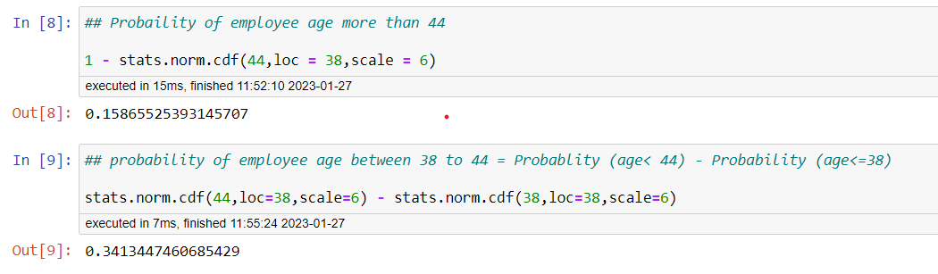

1. A training program for employees under the age of 30 at the center would be expected to attract about 36 employees.

Answer – True.

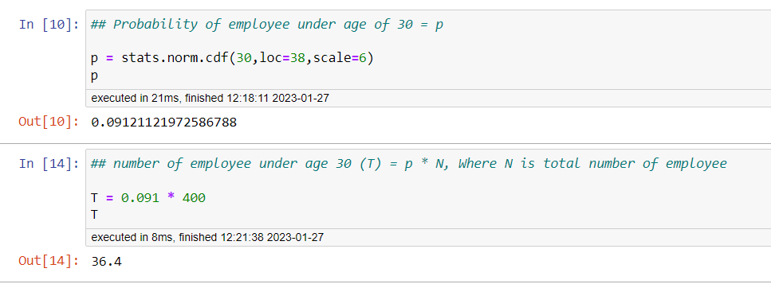

1. If *X1* ~ *N*(μ, σ2) and *X*2 ~ *N*(μ, σ2) are *iid* normal random variables, then what is the difference between 2 *X*1 and *X*1 + *X*2? Discuss both their distributions and parameters.

Answer –

The difference between 2(X1) and X1 + X2 is N(0, 6 σ^2).

**Step-by-step explanation:**

According to the Central Limit Theorem, any large sum of independent, identically distributed (IID) random variables is approximately Normal.

The Normal distribution is defined by two parameters, the mean, µ and the variance, σ^2 and written as X ~ N (µ, σ^2).

Given X1 ~ N (µ, σ^2) AND X2 ~ N (µ, σ^2) are two independent identically distributed random variables.

From the properties of normal random variables,

if X ~ N (µ1, (σ1)^2) and Y ~ N (µ2, (σ2)^2) are two independent identically distributed random variables then

* the sum of normal random variables is given by

,

* and the difference of normal random variables is given by



* When  , the product of X is given by



* When  , the linear combination of X and Y is given by



Given to find, 2(X1)

Thus, following the property of multiplication, we get

2(X1) ~ N (2µ, 2^2(σ^2)) = N (2µ, 4σ^2)

and following the property of addition,

X1 + X2 ~ N (µ + µ, σ^2 + σ^2) = N (2µ, 2σ^2)

And the difference between the two is given by

2X1 – (X1 + X2) ~ N (2µ - 2µ, 4σ^2 + 2σ^2) = N (0, 6σ^2)

The mean of 2X1 and X1 + X2 is same but the var (σ^2) of 2X1 is 2 times more than the variance of X1+X2.

The difference between the two says that the two given variables are identically and independently distributed

1. Let X ~ N (100, 202). Find two values, *a* and *b*, symmetric about the mean, such that the probability of the random variable taking a value between them is 0.99.
2. 90.5, 105.9
3. 80.2, 119.8
4. 22, 78
5. 48.5, 151.5
6. 90.1, 109.9

Answer – D. 48.5, 151.5

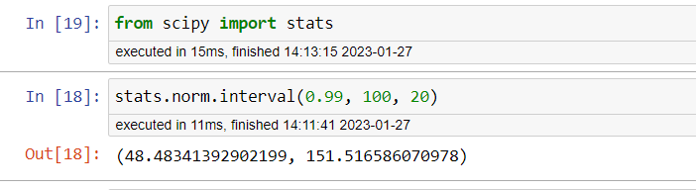

1. Consider a company that has two different divisions. The annual profits from the two divisions are independent and have distributions Profit1 ~ N(5, 32) and Profit2 ~ N(7, 42) respectively. Both the profits are in $ Million. Answer the following questions about the total profit of the company in Rupees. Assume that $1 = Rs. 45
2. Specify a Rupee range (centered on the mean) such that it contains 95% probability for the annual profit of the company.
3. Specify the 5th percentile of profit (in Rupees) for the company
4. Which of the two divisions has a larger probability of making a loss in a given year?

Answer –

1. Range = Rs. 99 million to 981 million

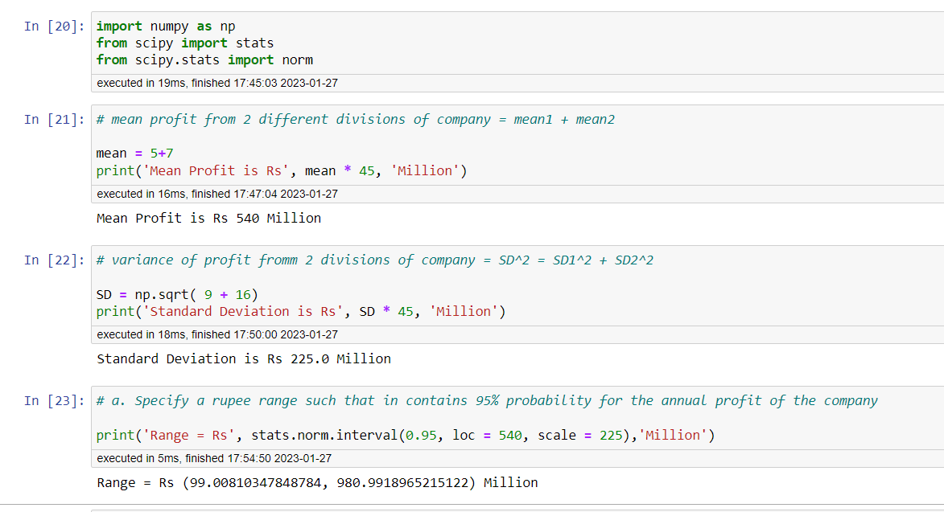

1. 5th percentile of profit (in Million Rupees) is 170.0

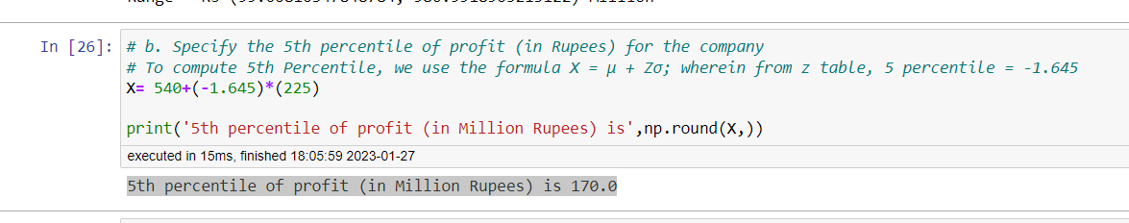

1. Division 1 is having more chances of making loss.

